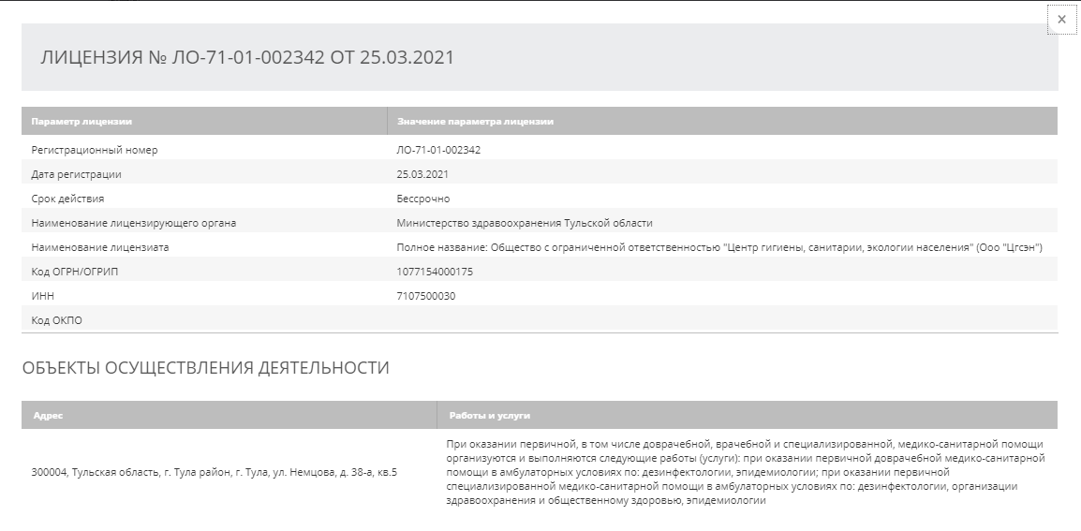

https://roszdravnadzor.gov.ru/services/licenses?qrguid=492ed9a42d10b85d6d8cb0ef9c061da7

